C950 Task-2 WGUPS Write-Up

(Task-2: The implementation phase of the WGUPS Routing Program).

(Zip your source code and upload it with this file)

05/27/2024

C950 Data Structures and Algorithms II

# A. Hash Table

Hash Table Screenshots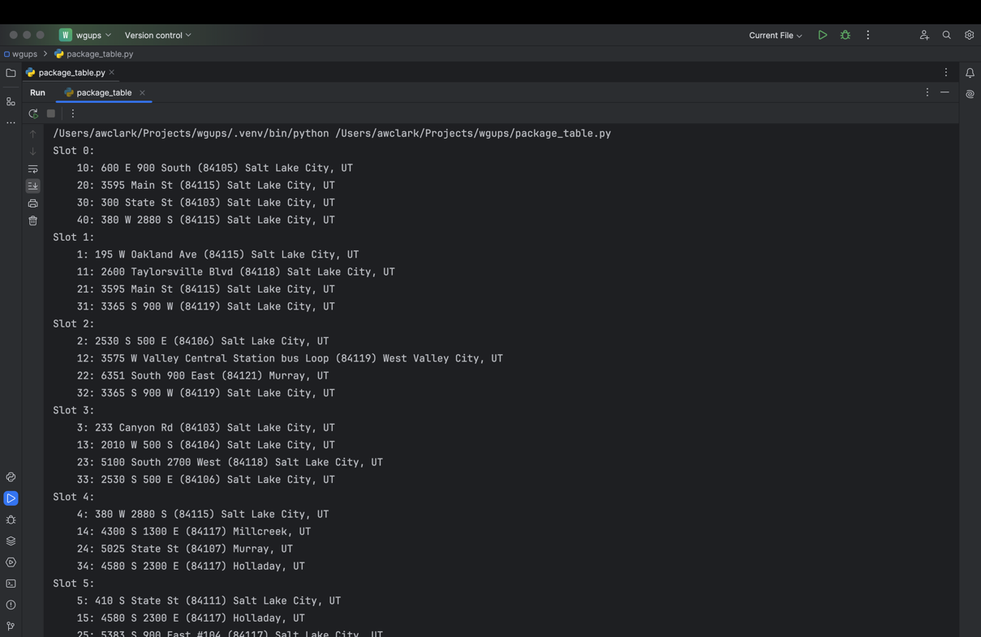 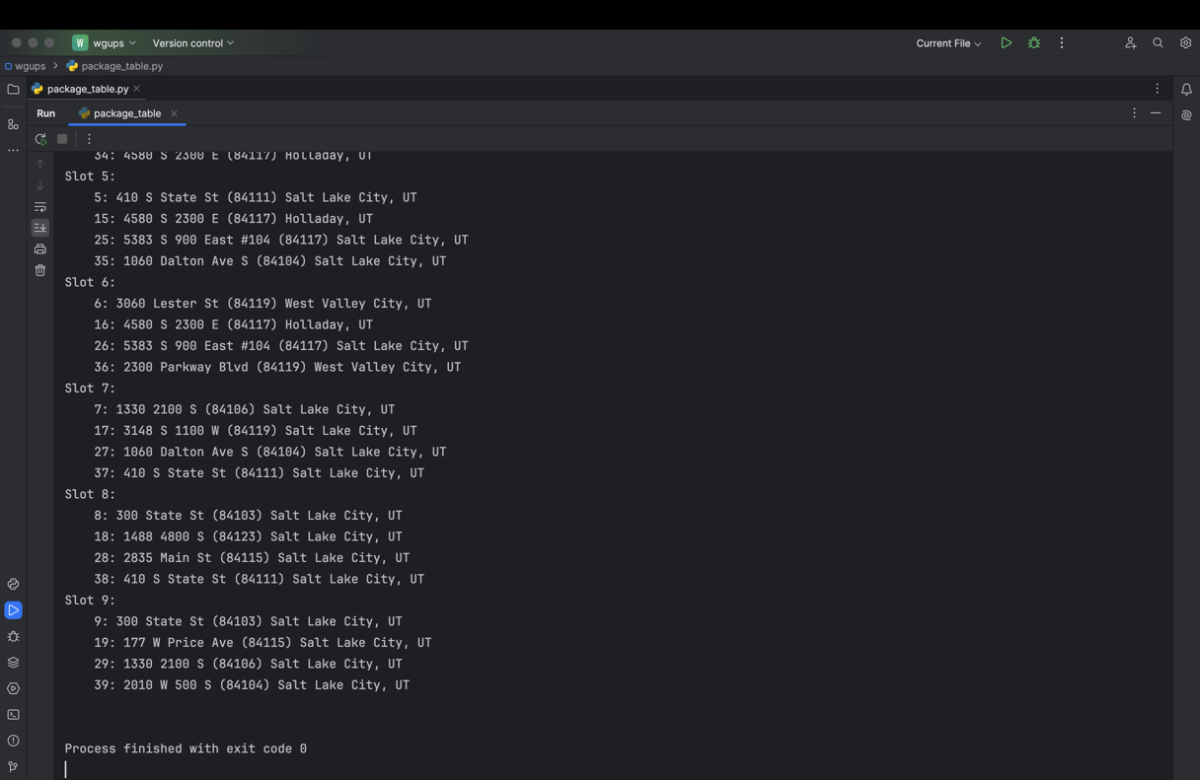

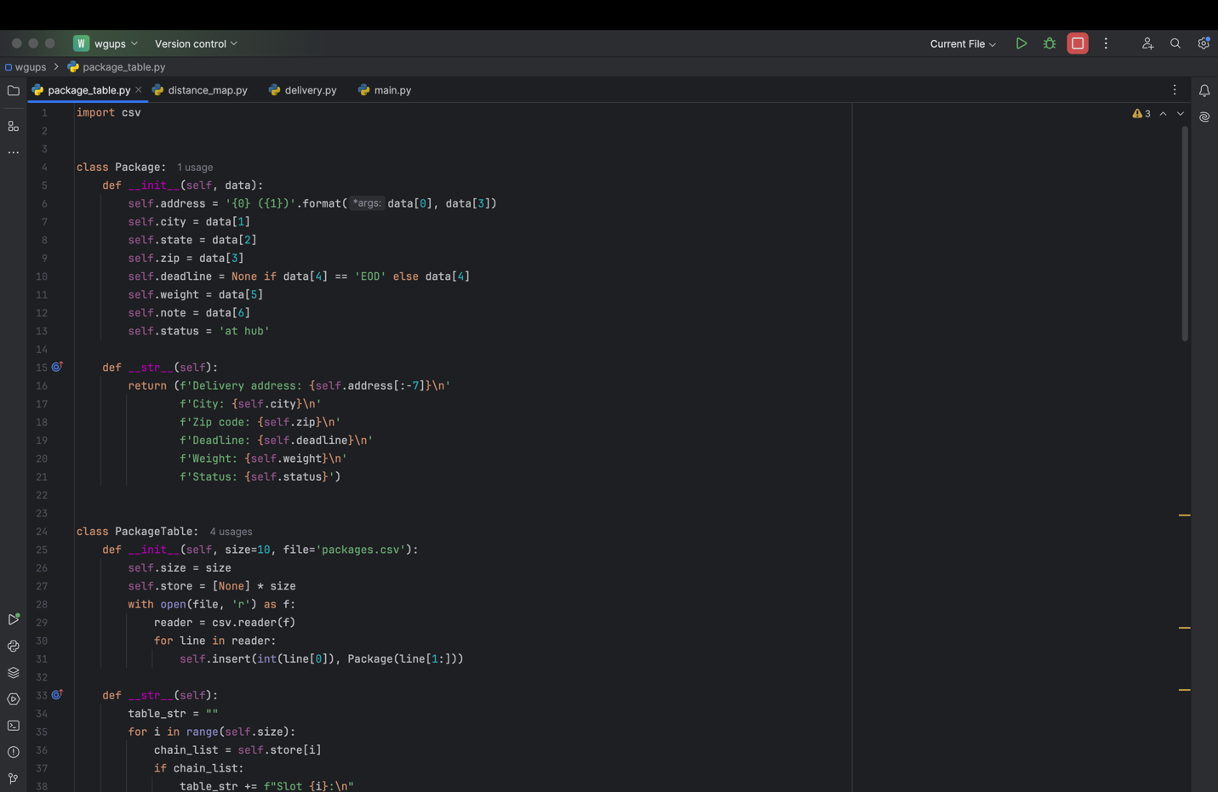

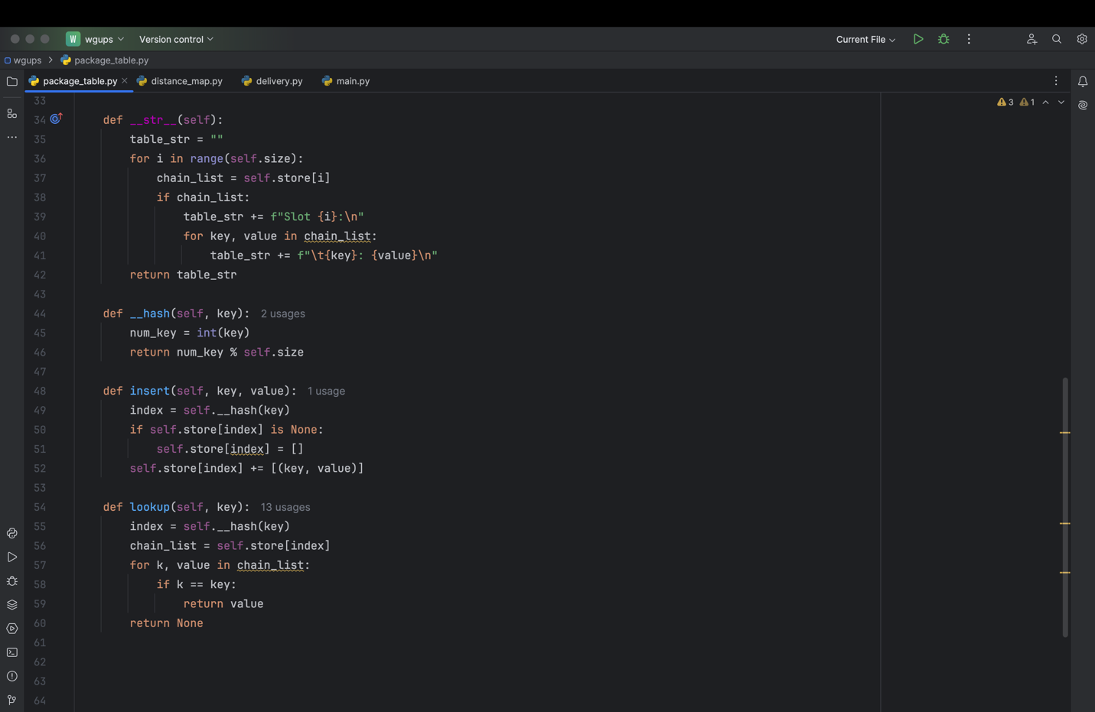

# B. Look-Up Functions

Look-up function screenshot

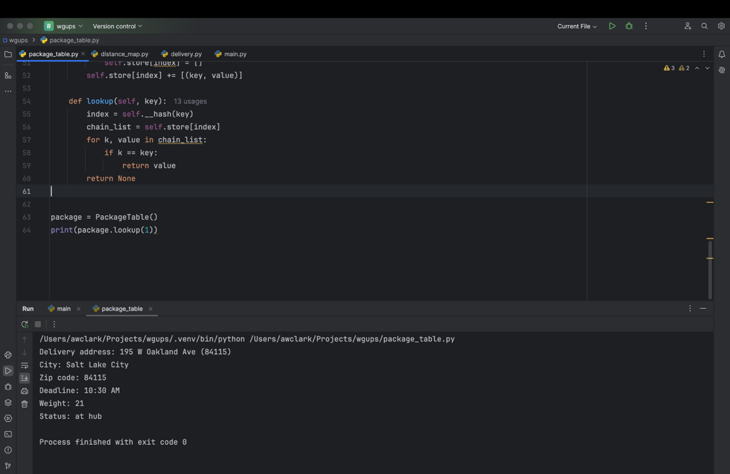

# C. Original Code

Major code blocks screenshots go here showing implementation

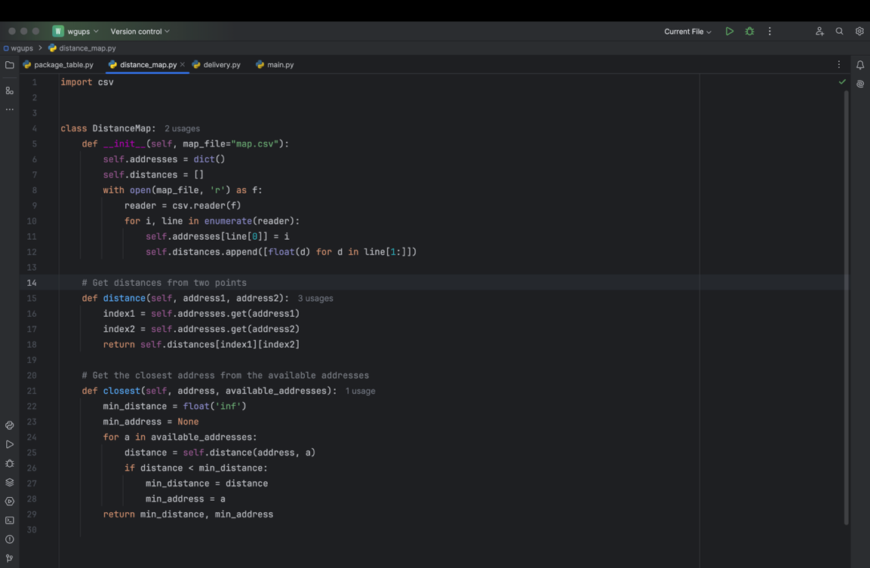

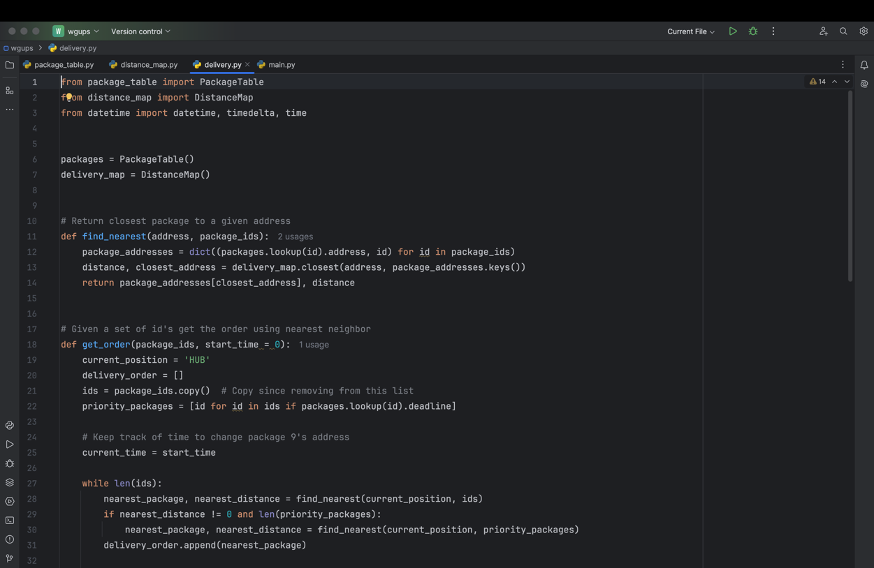

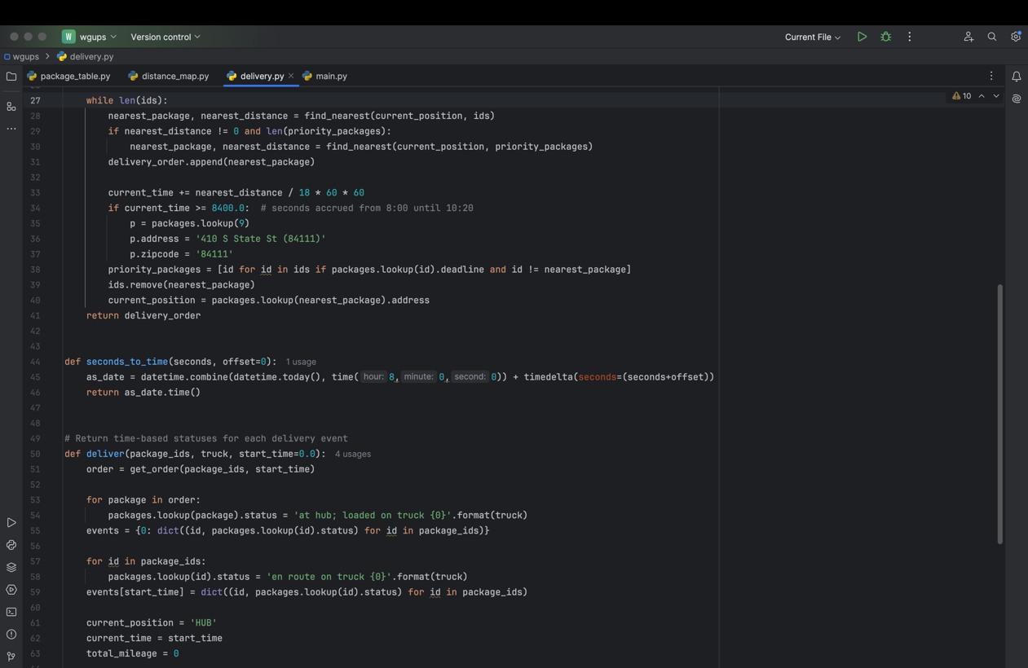

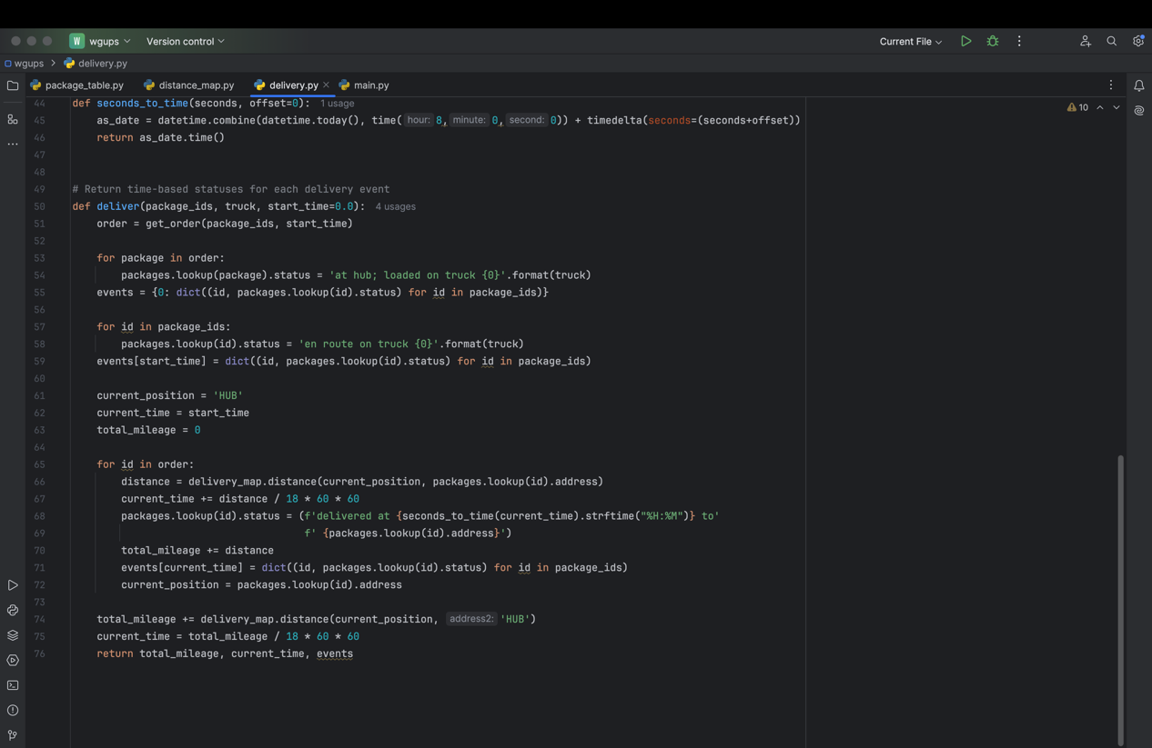

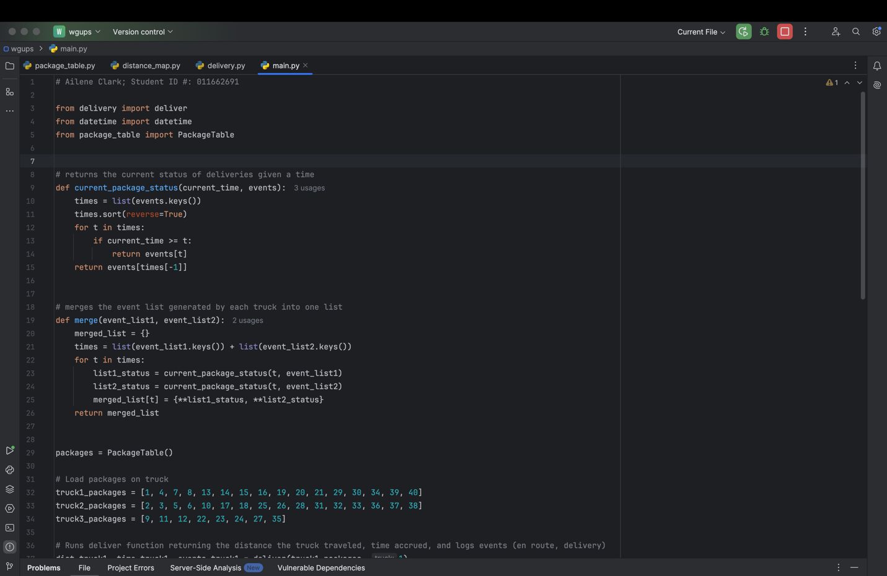

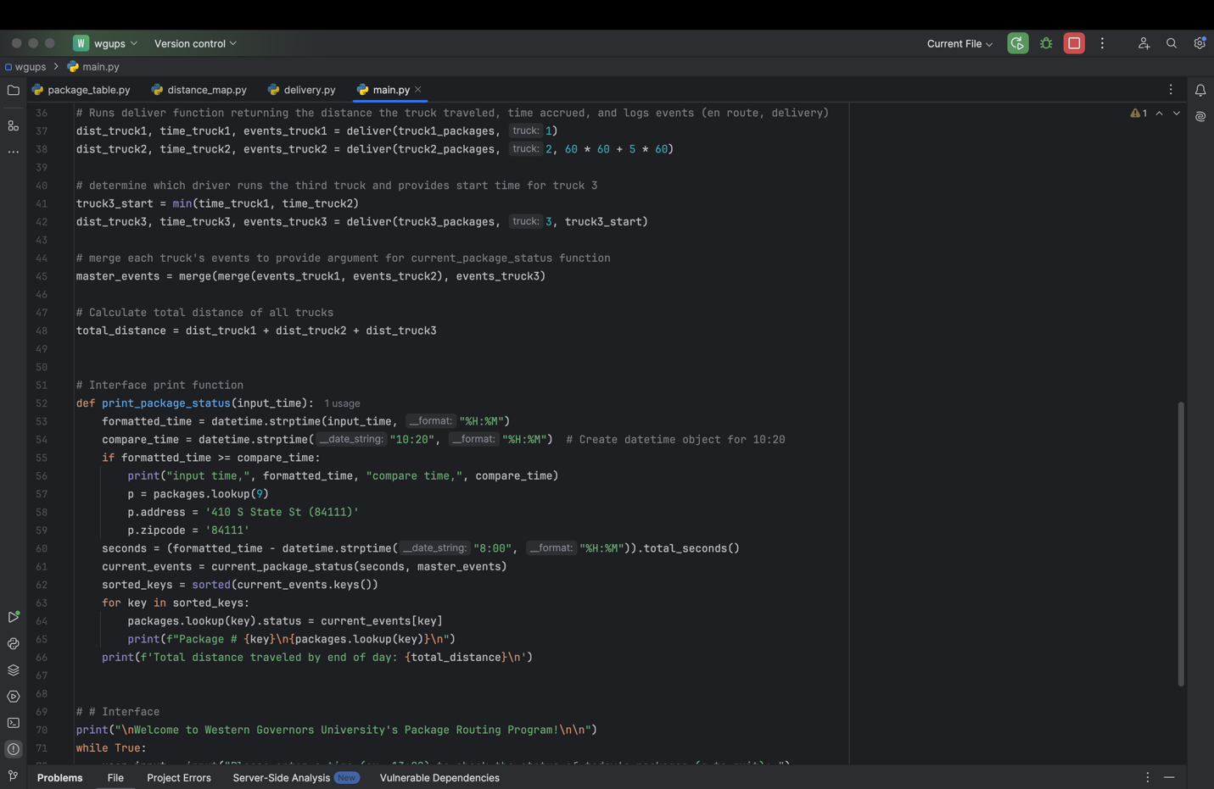

# C1. Identification Information

main.py screenshot goes here showing Student ID



# C2. Process and Flow Comments

Some code blocks screenshots go here showing comments 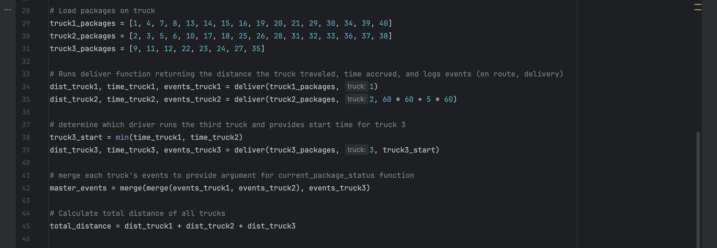

# D. Interface

Interface screenshot goes here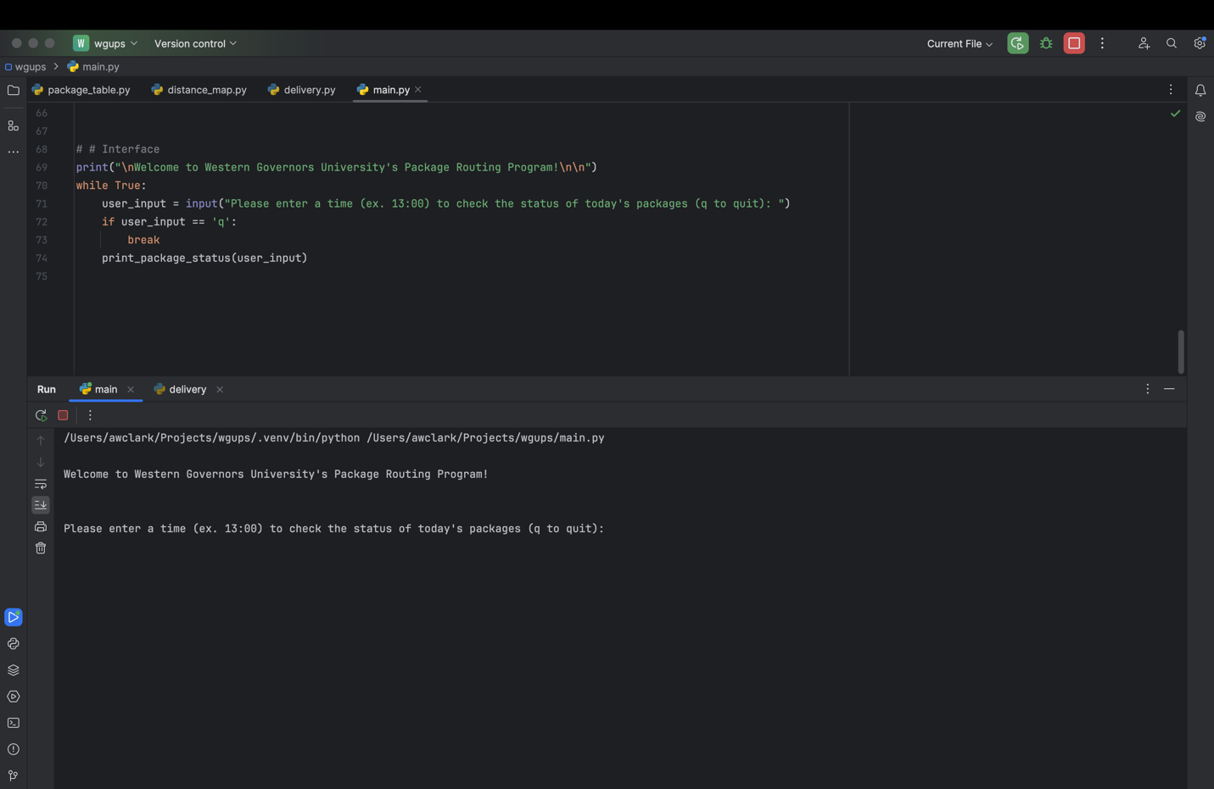

# D1. First Status Check

Screen shot goes here

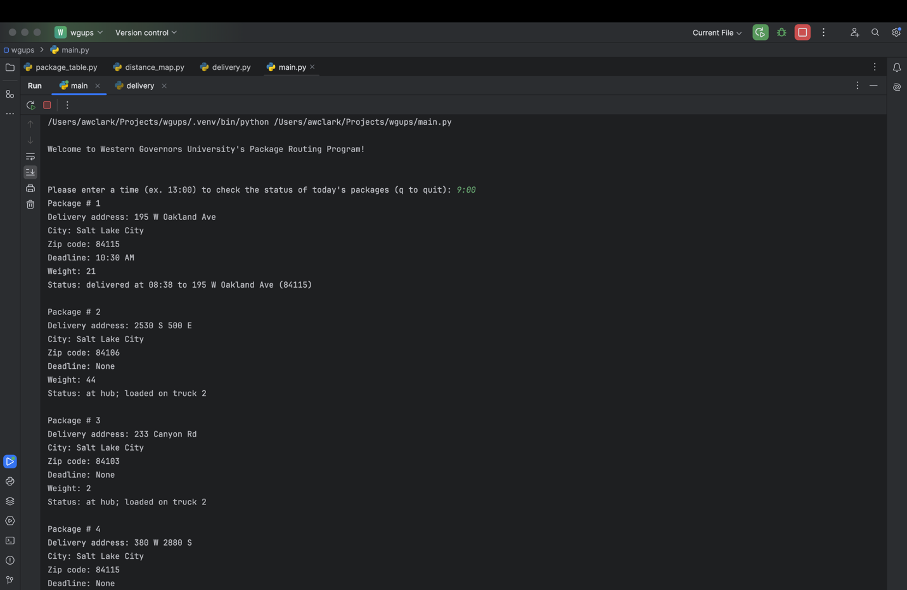

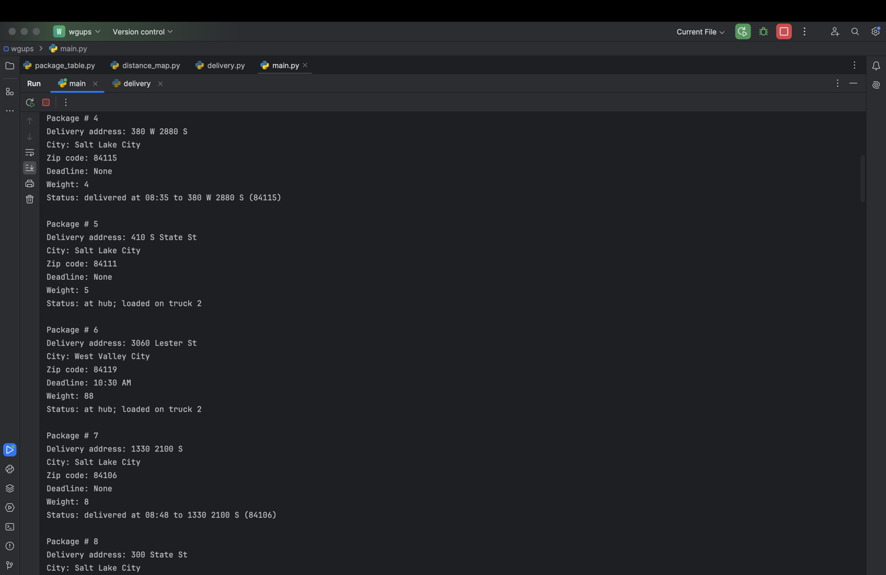

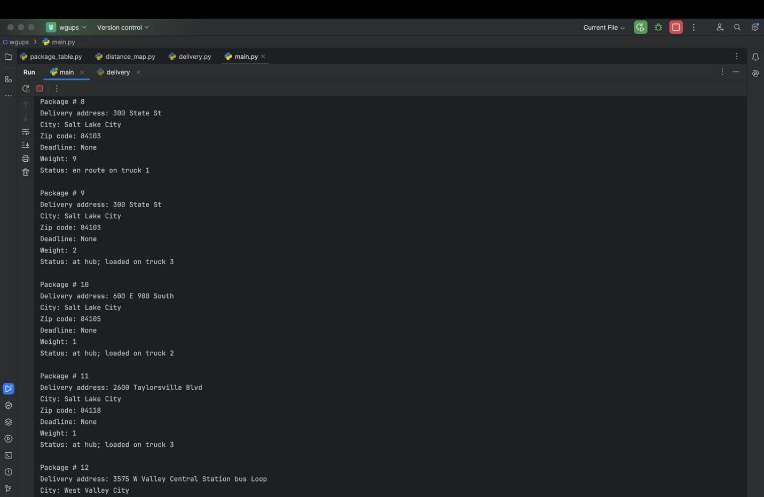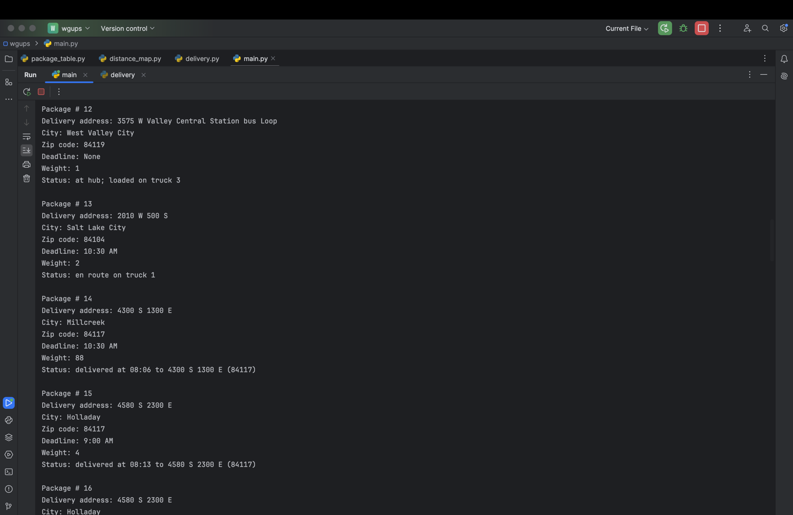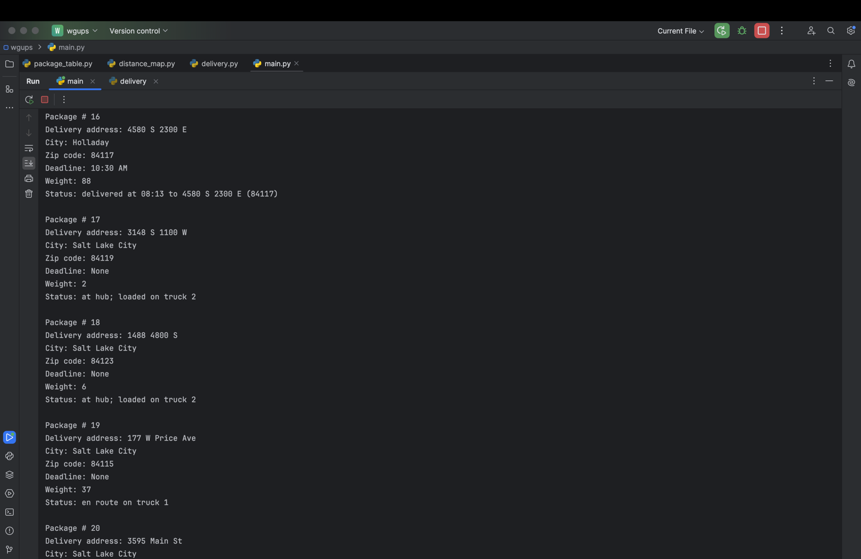

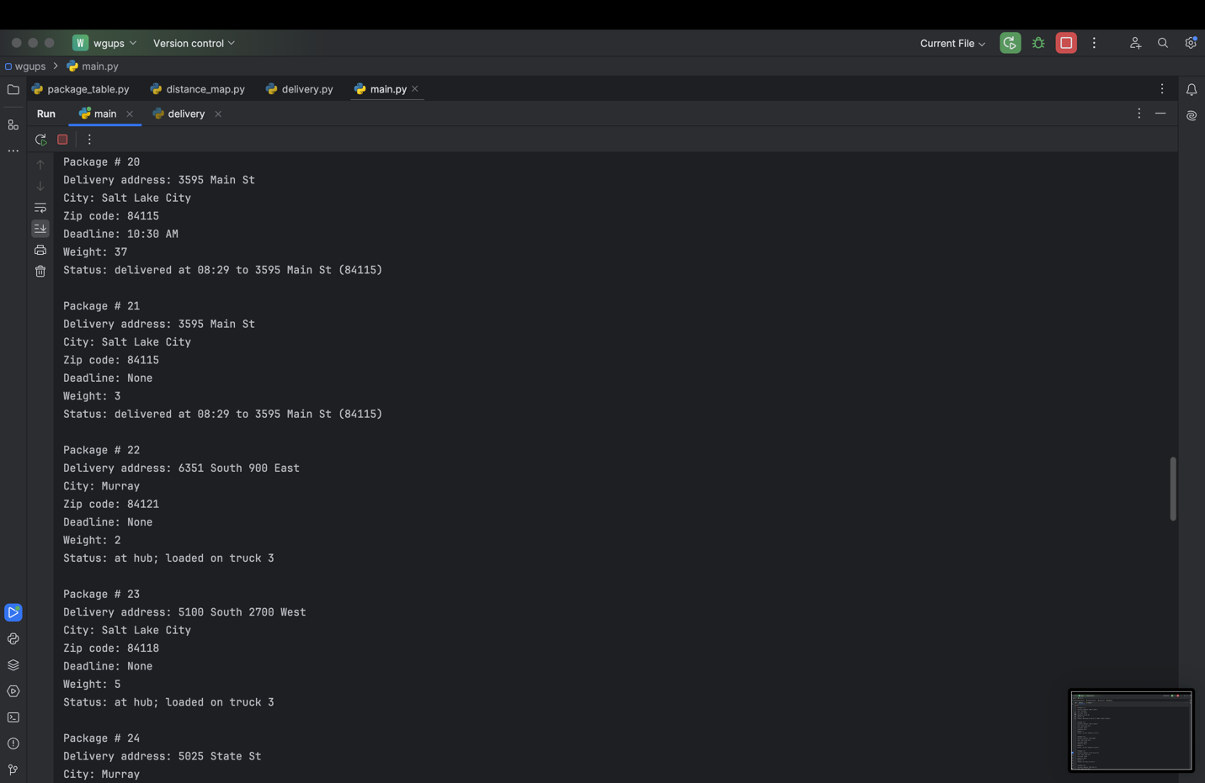

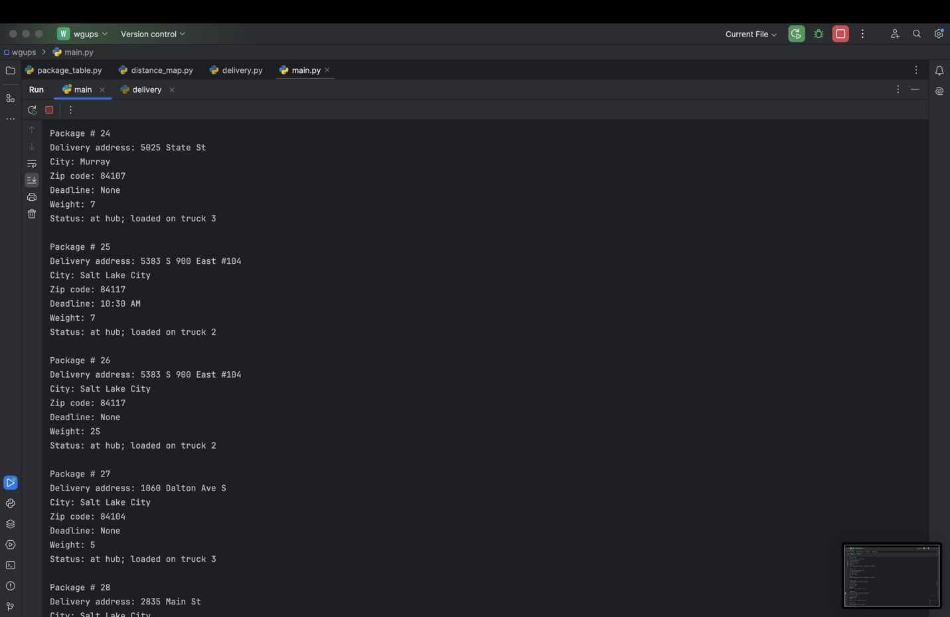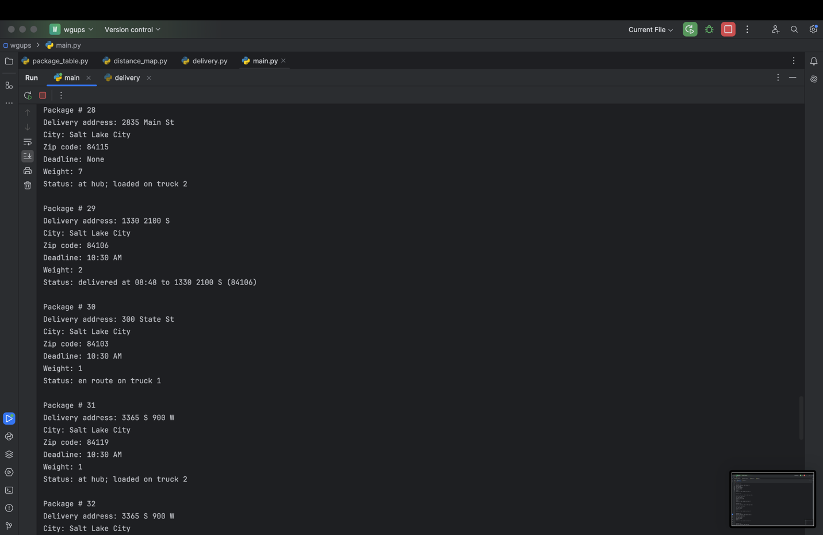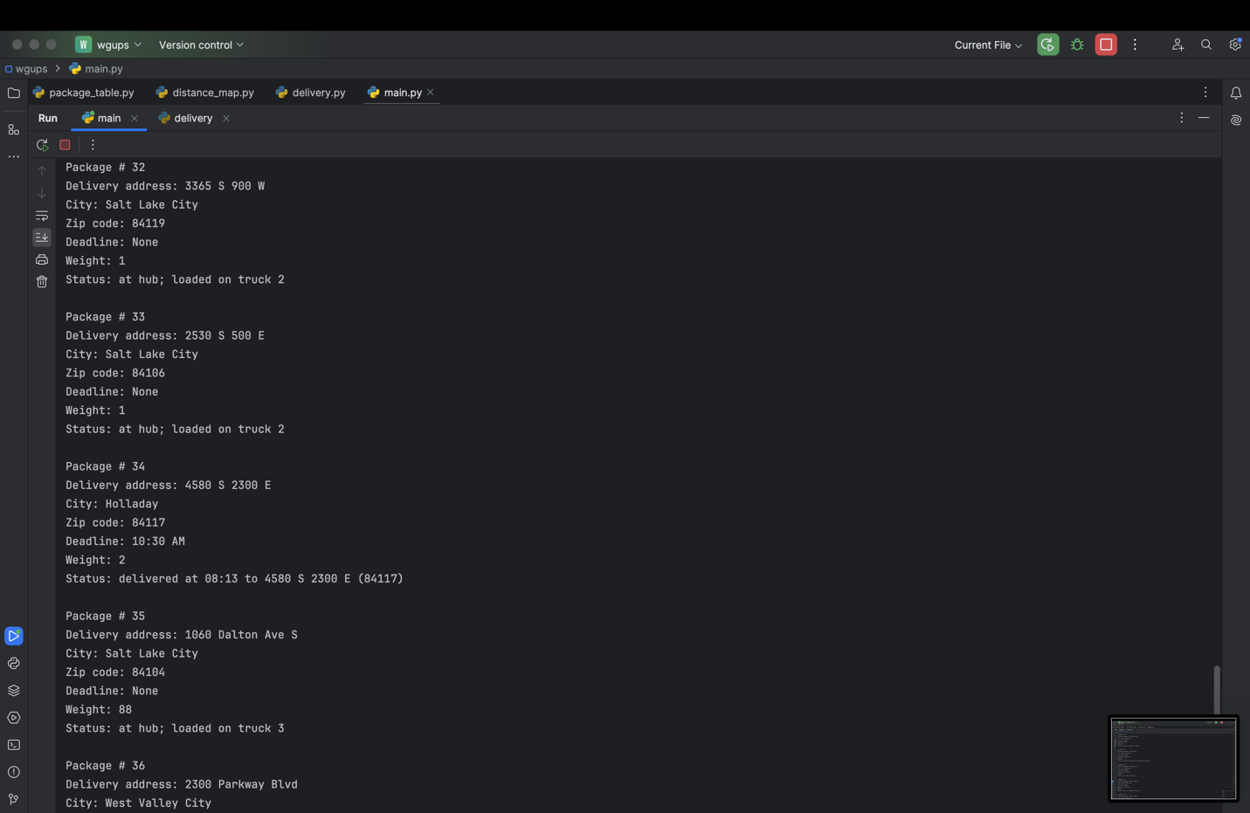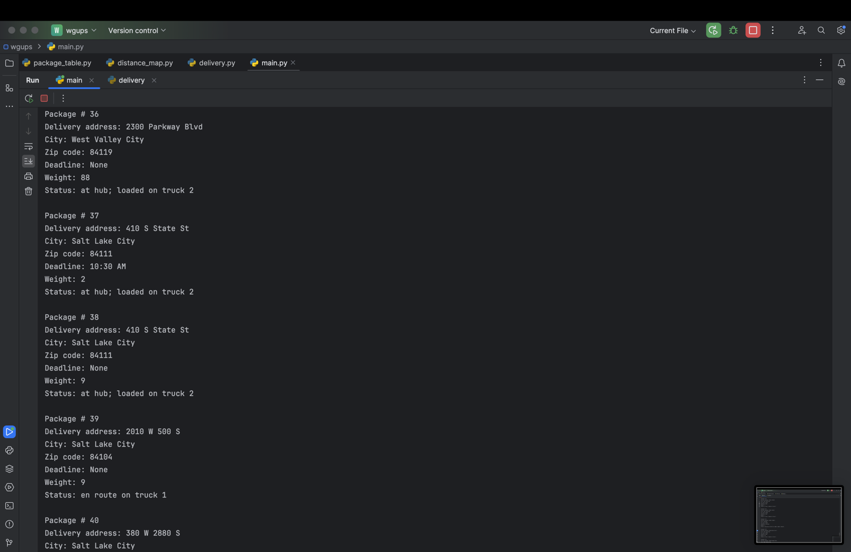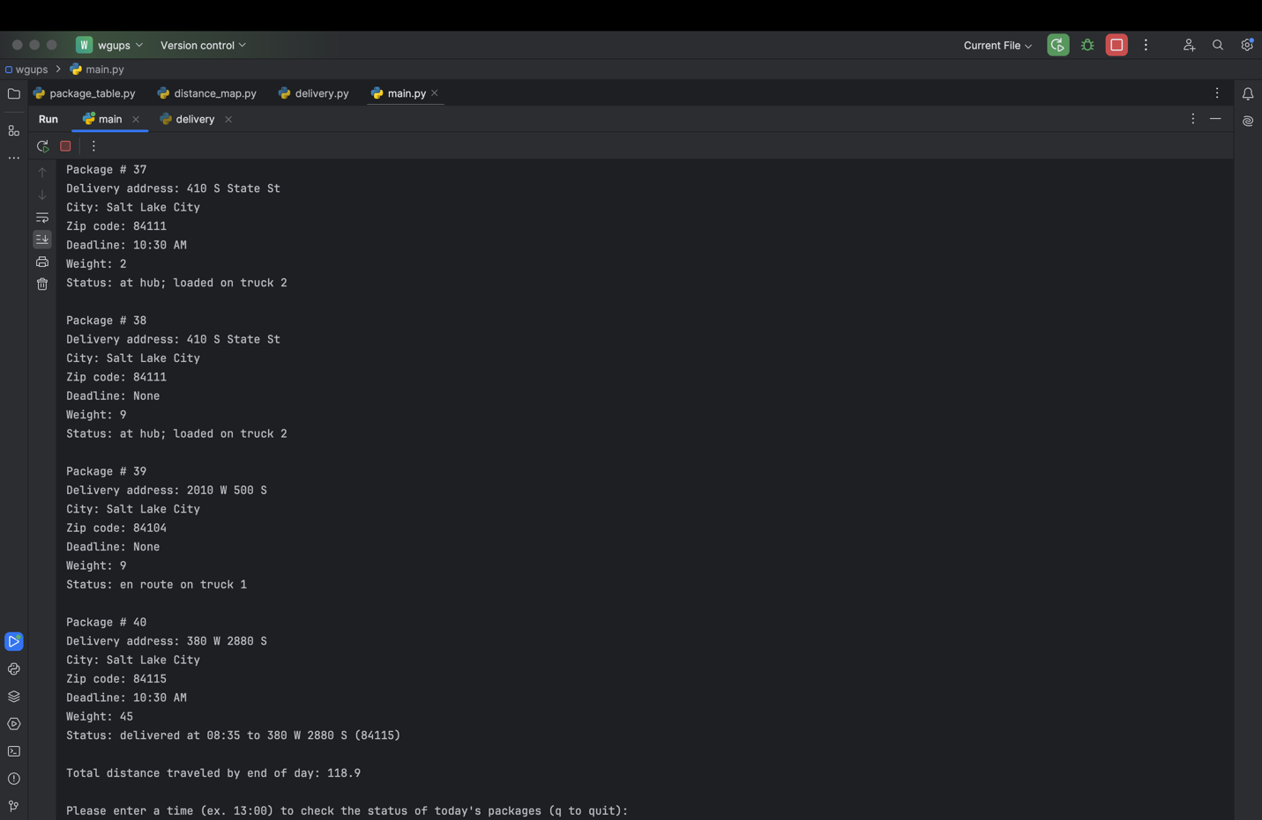

# D2. Second Status Check

Screenshot goes here

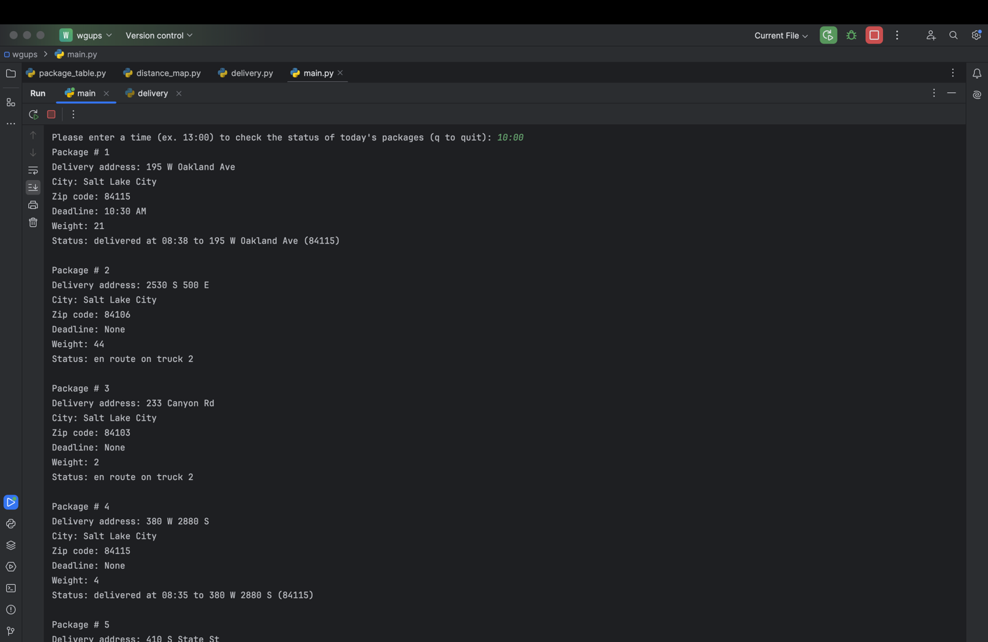

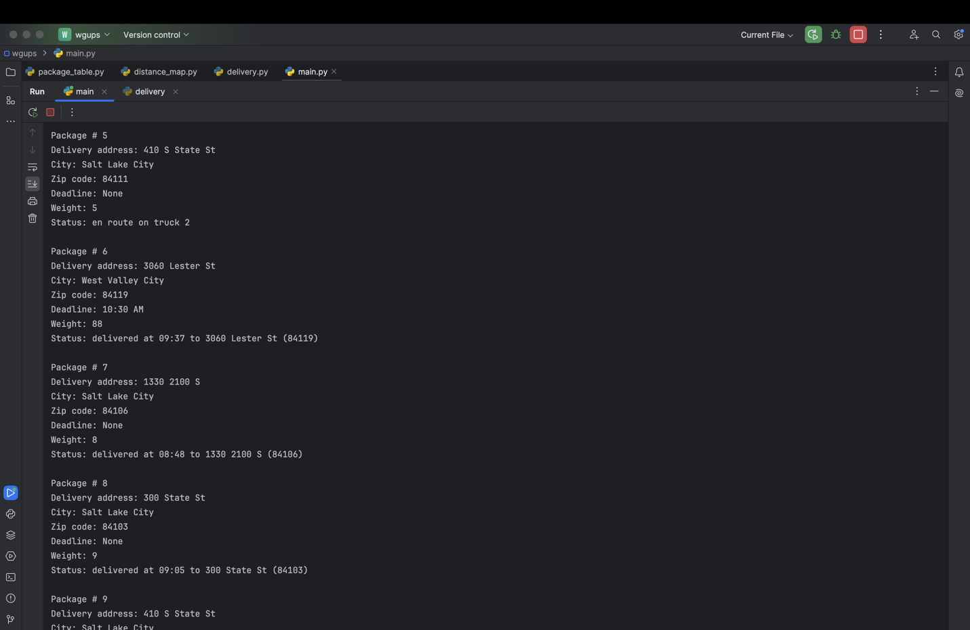

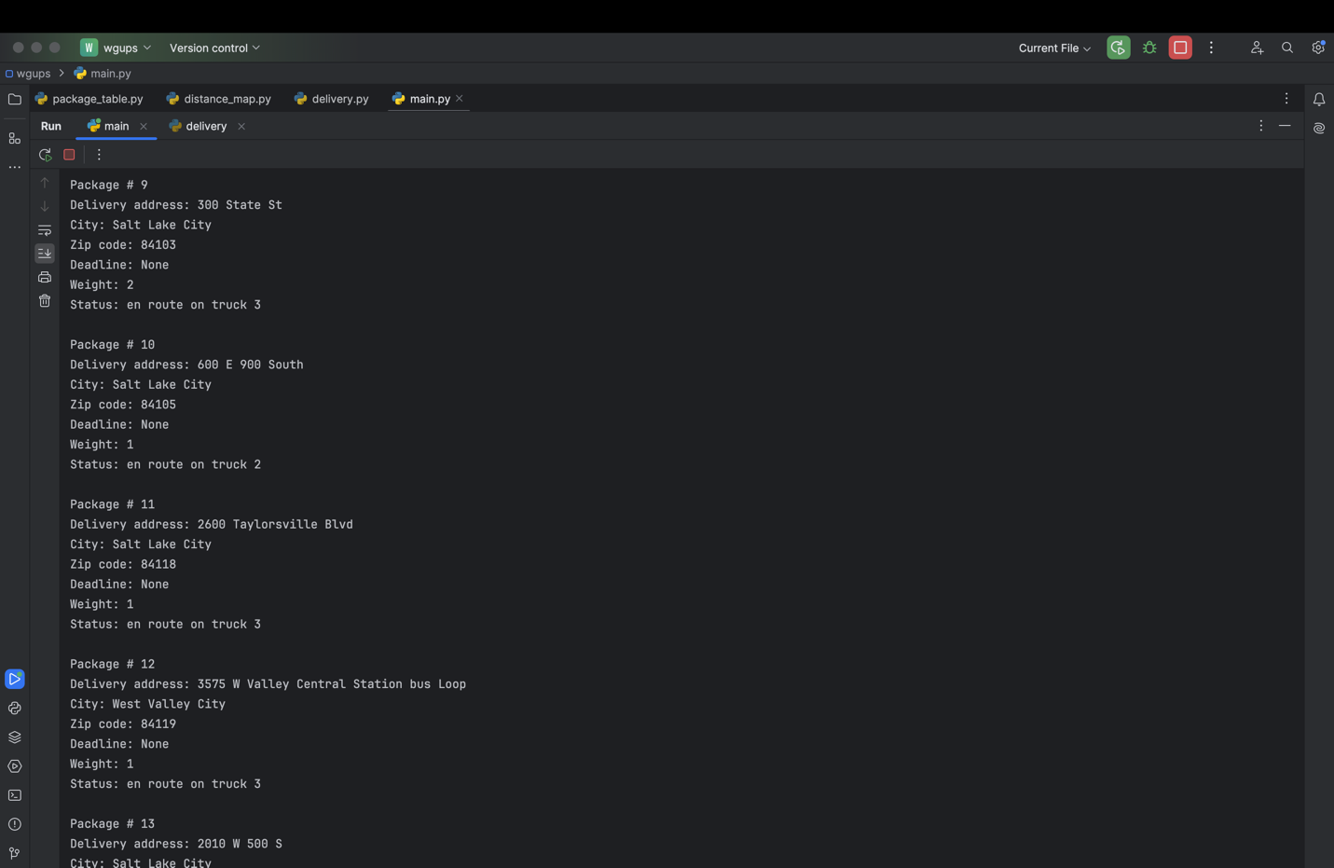

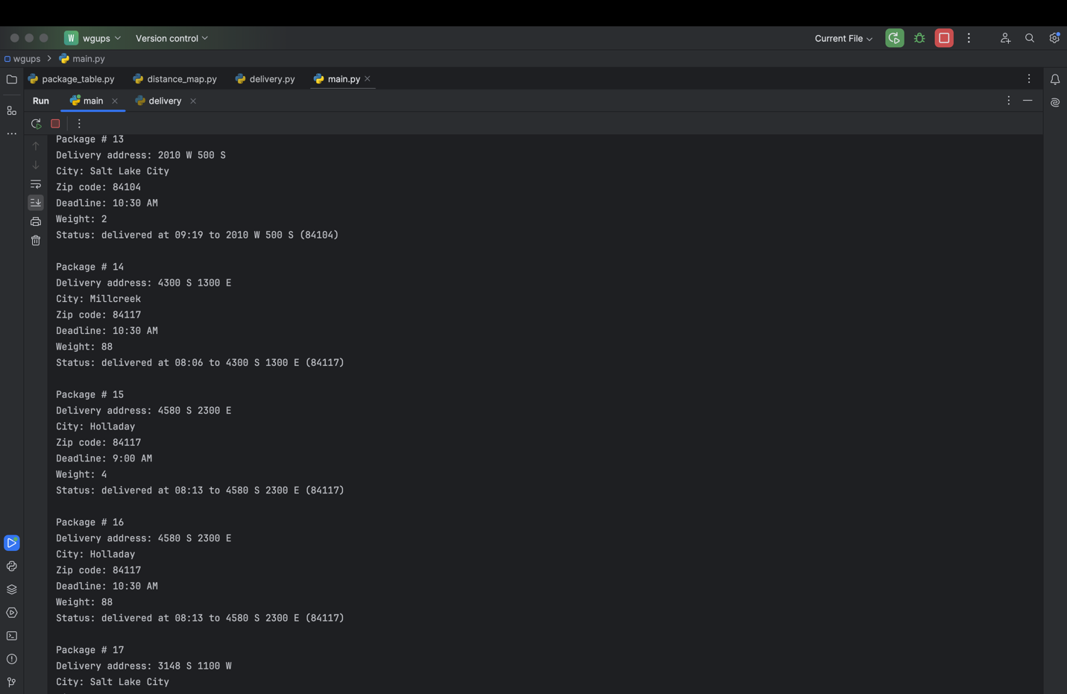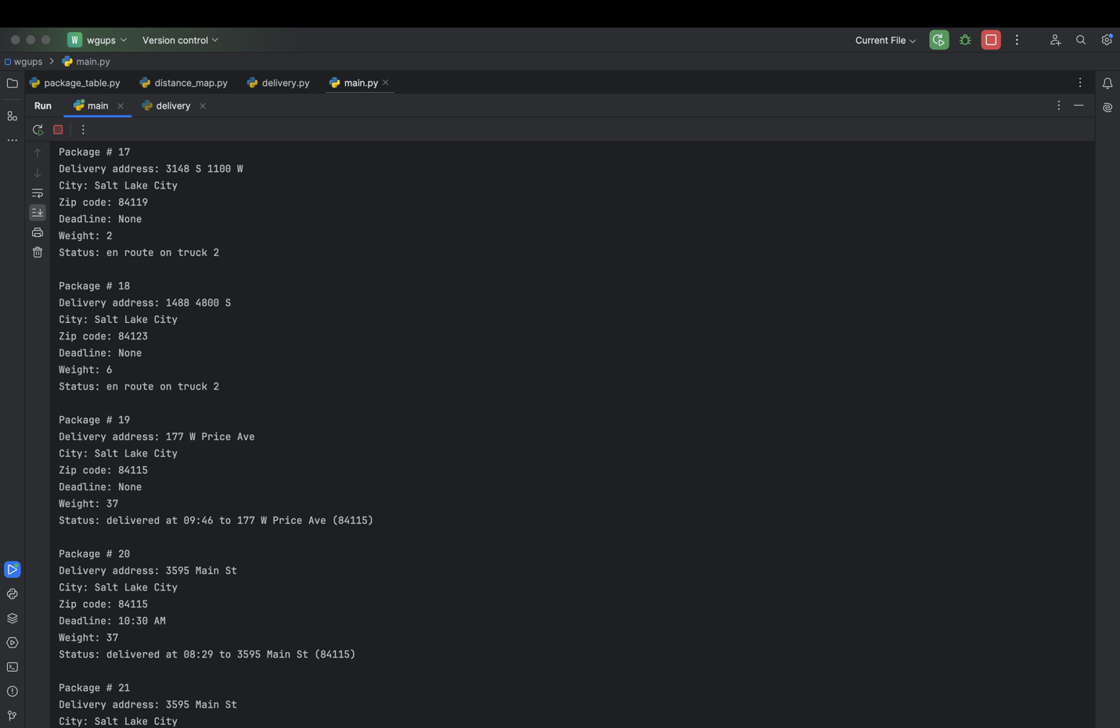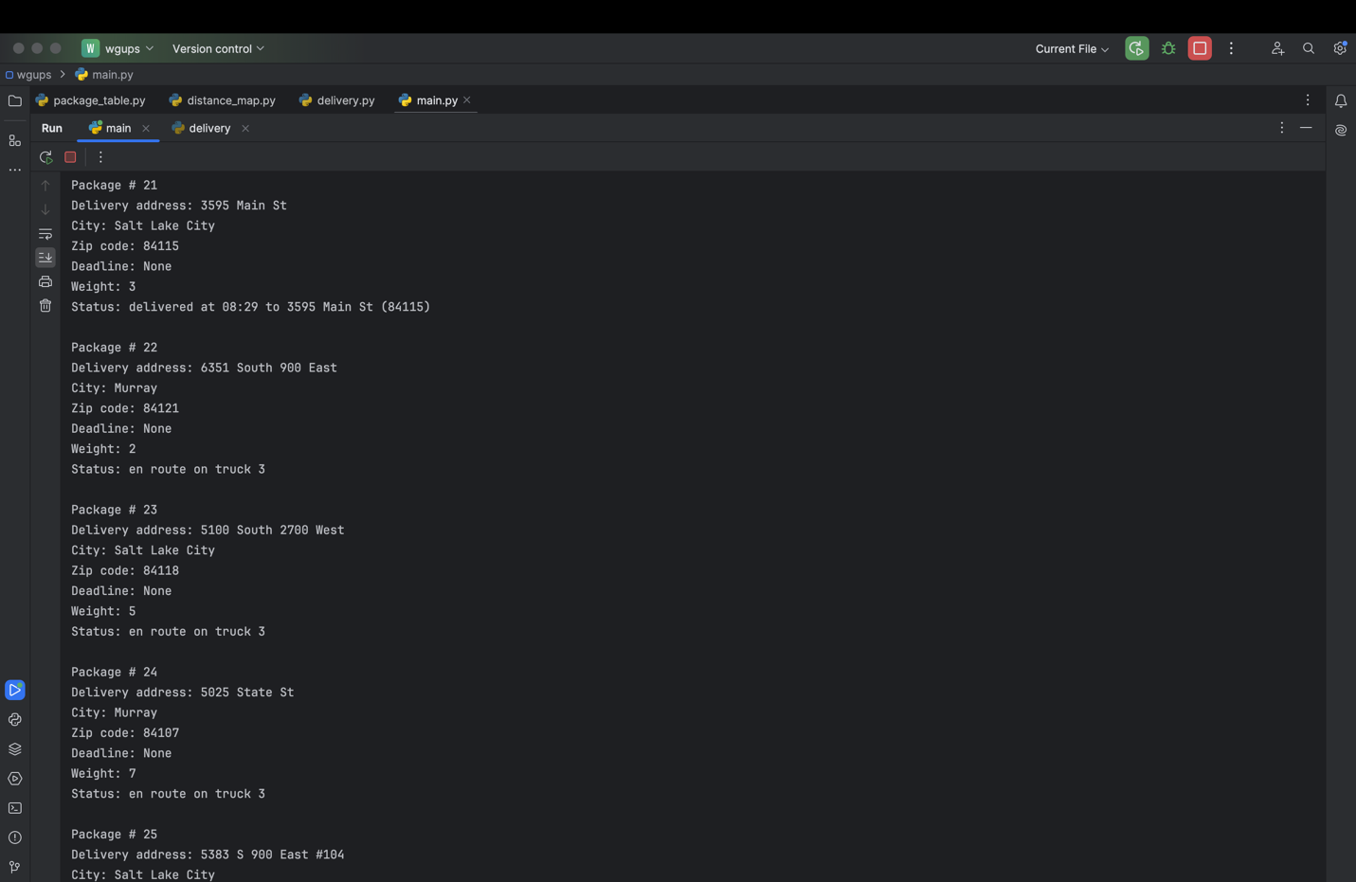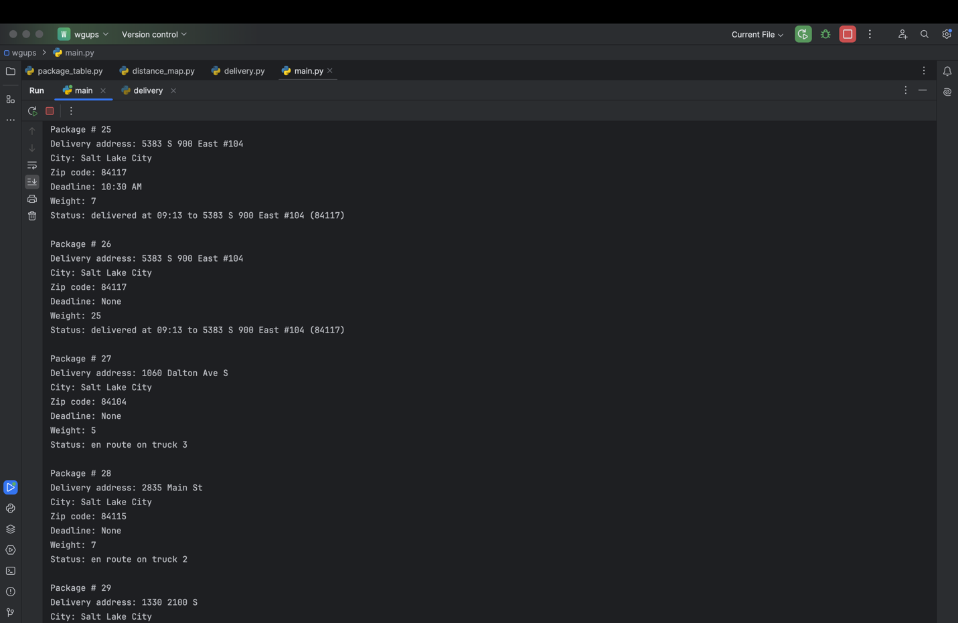

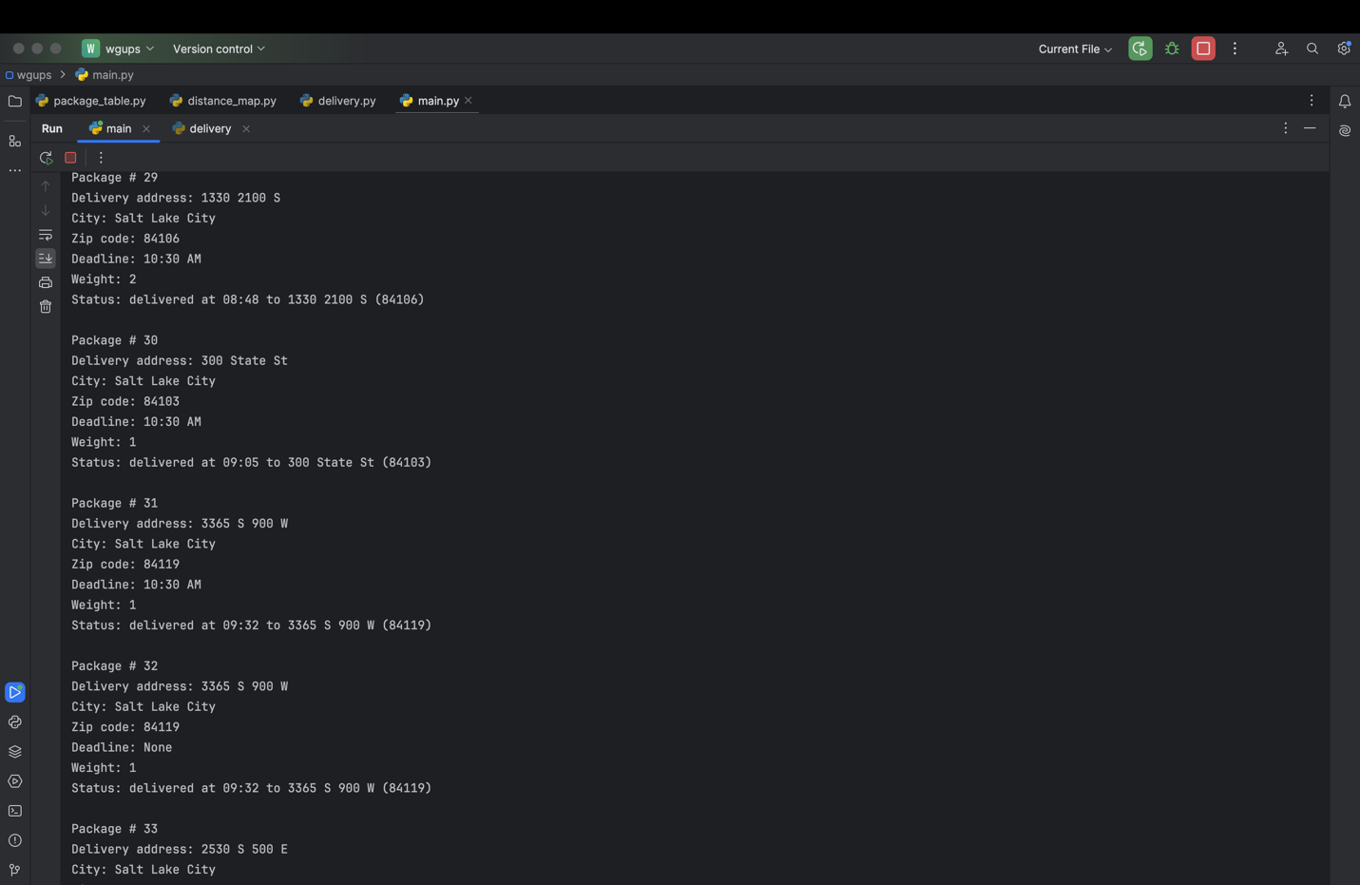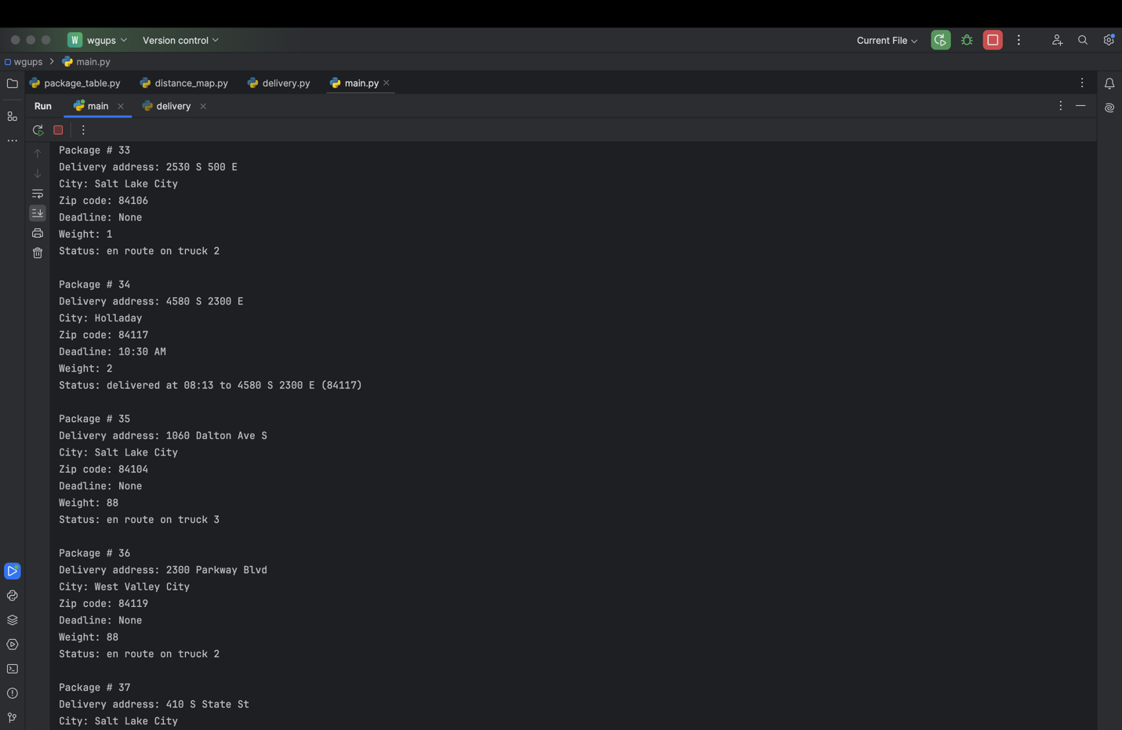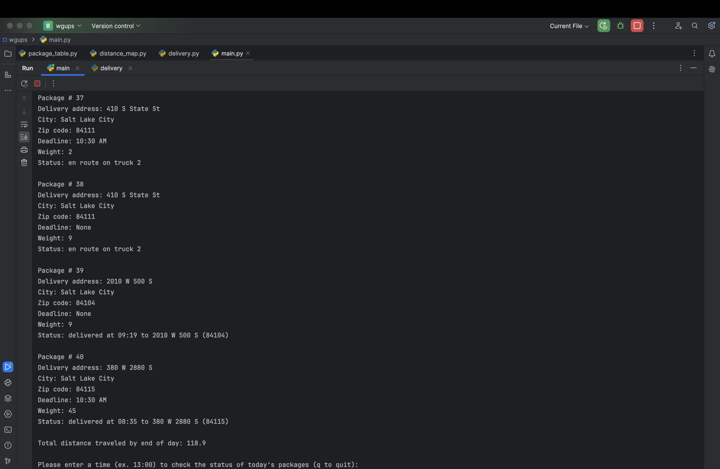

# D3. Third Status Check

Screenshot goes here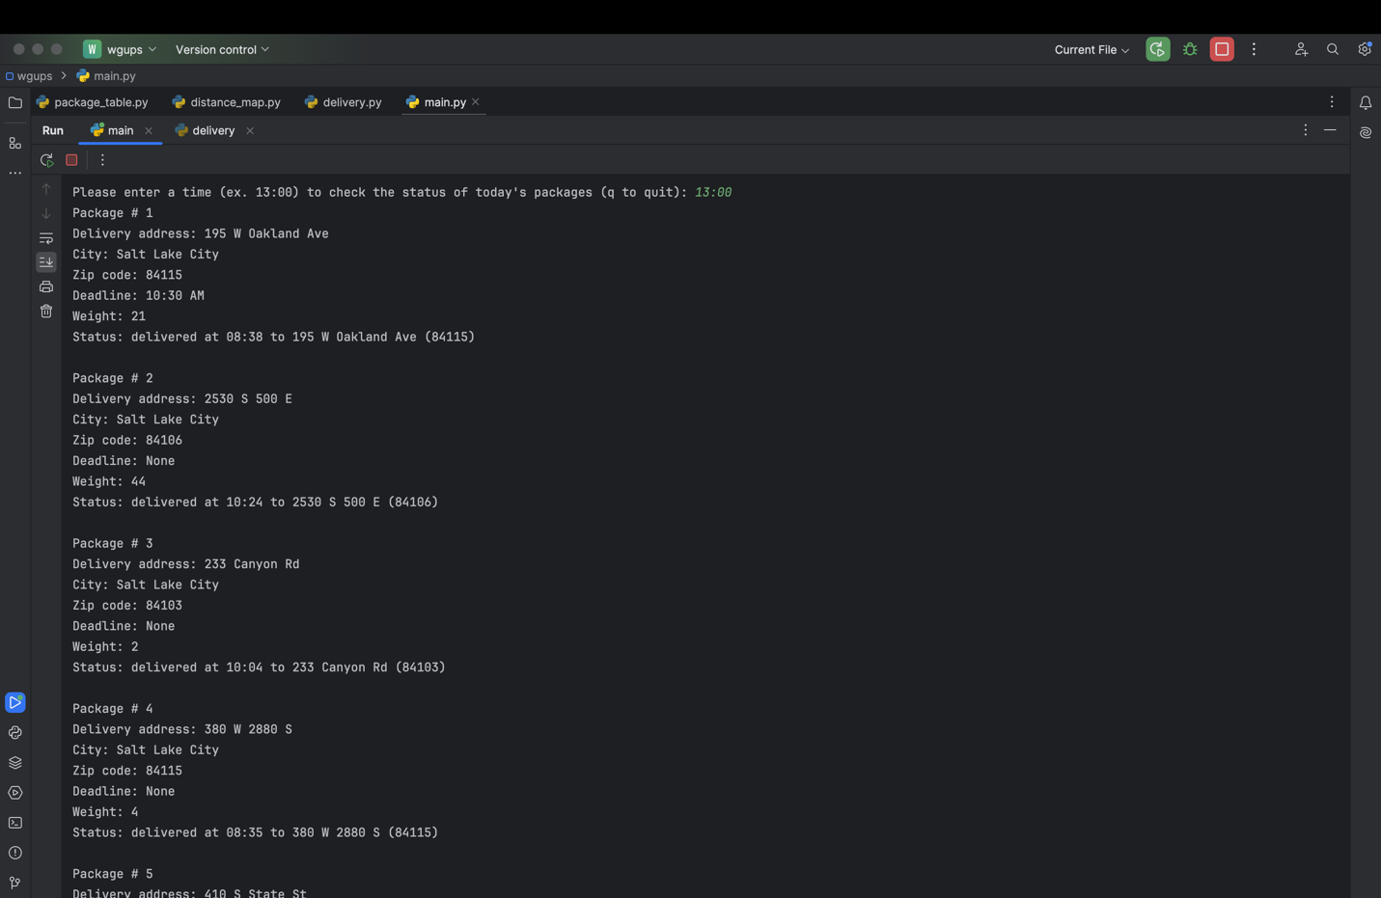

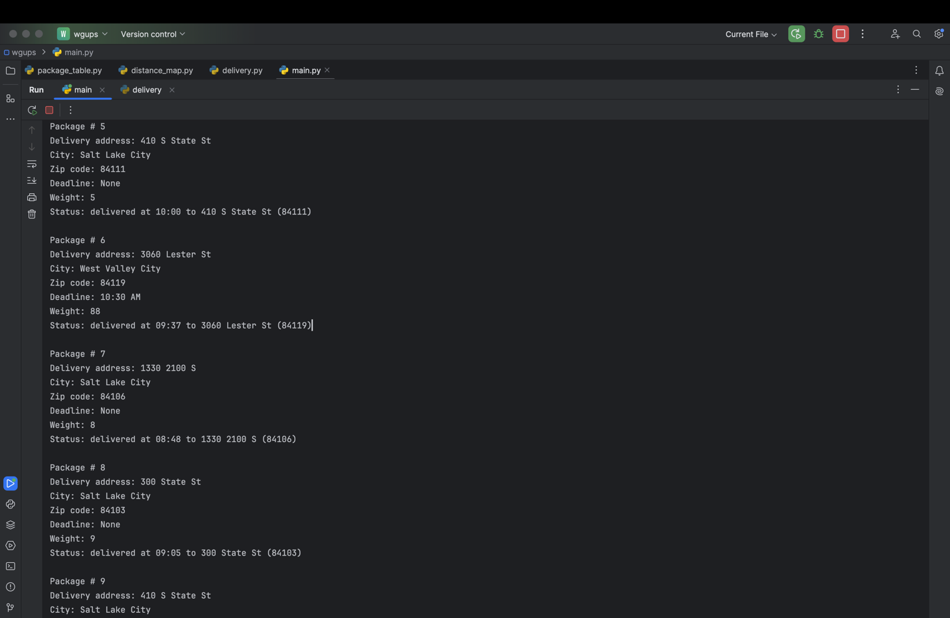

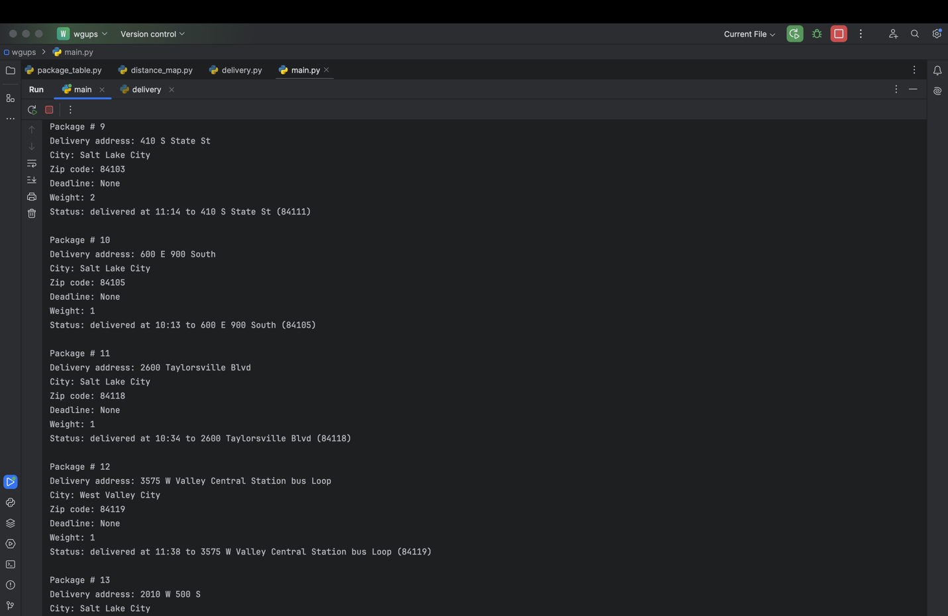

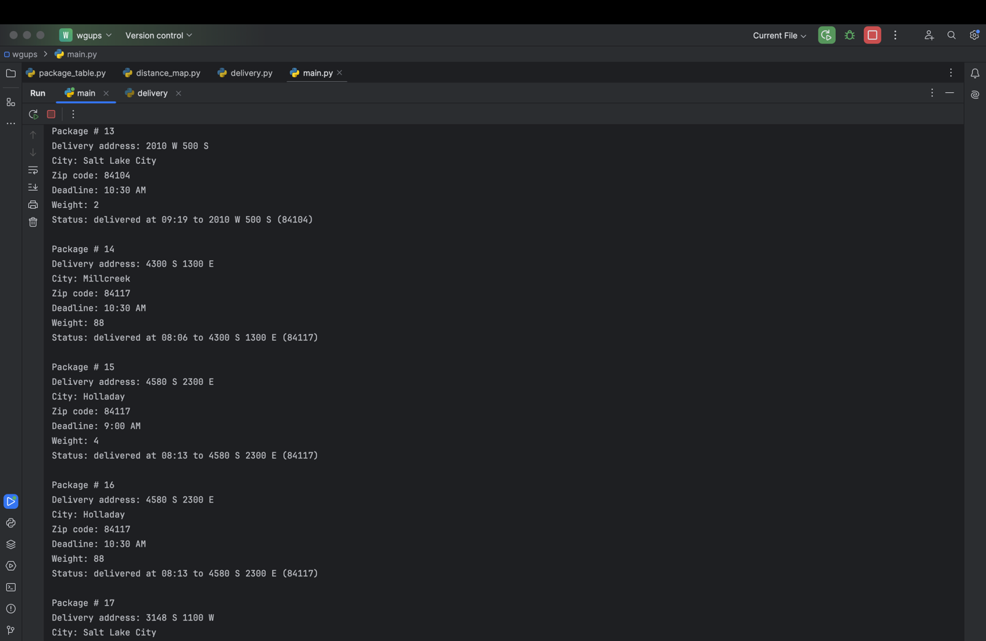

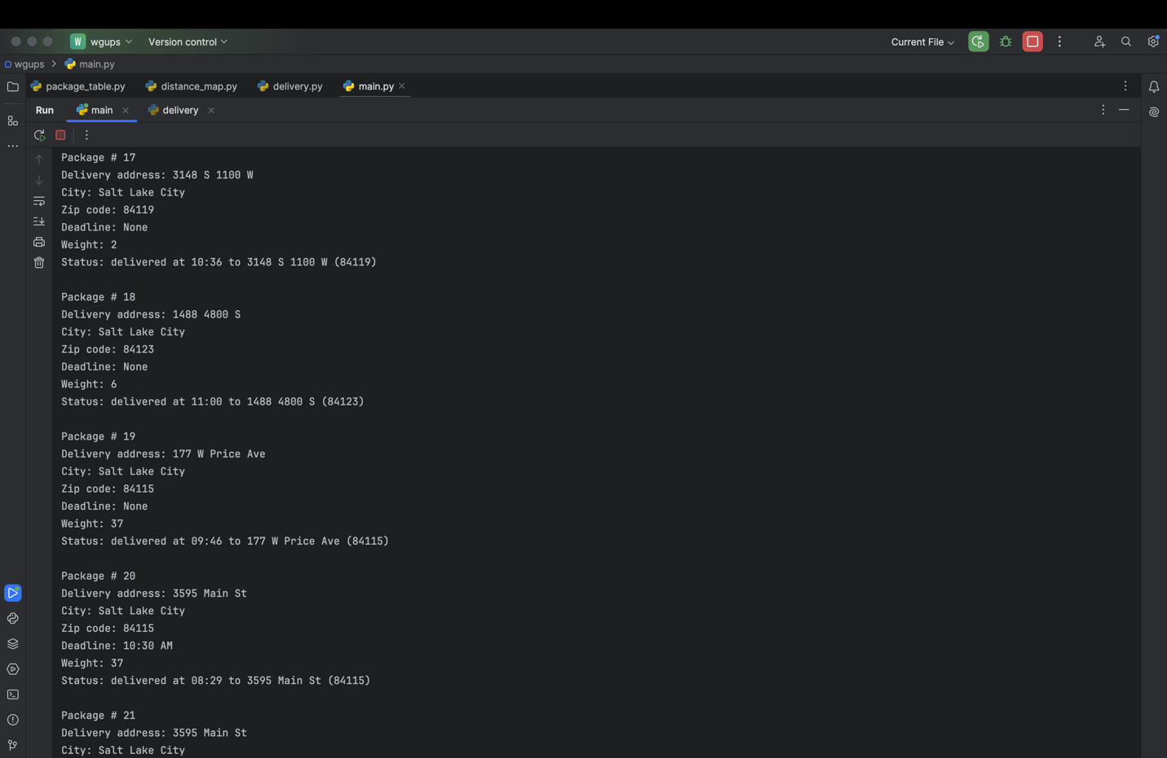

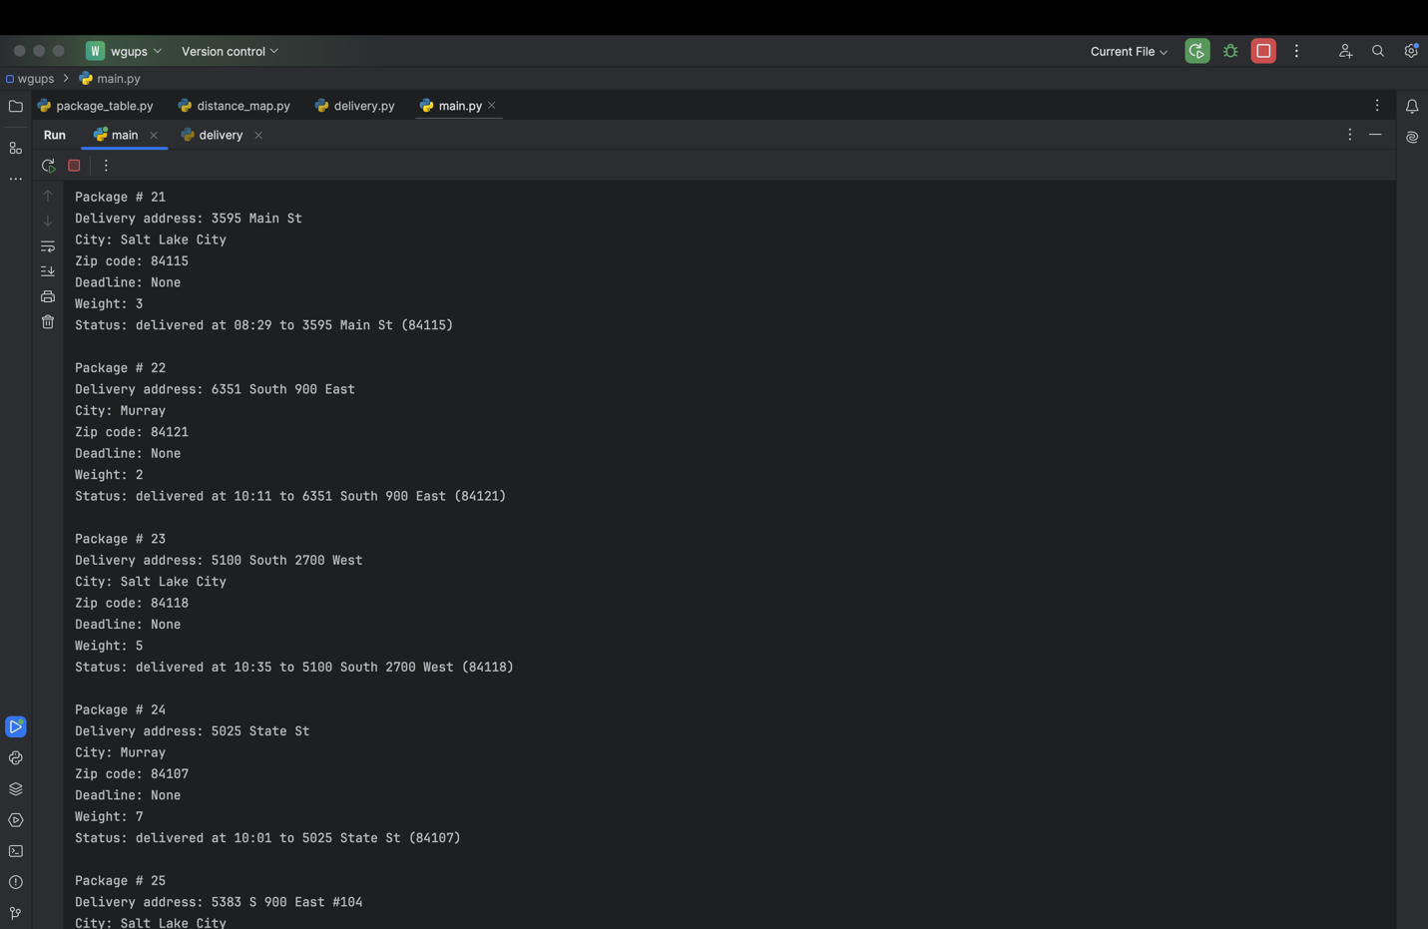

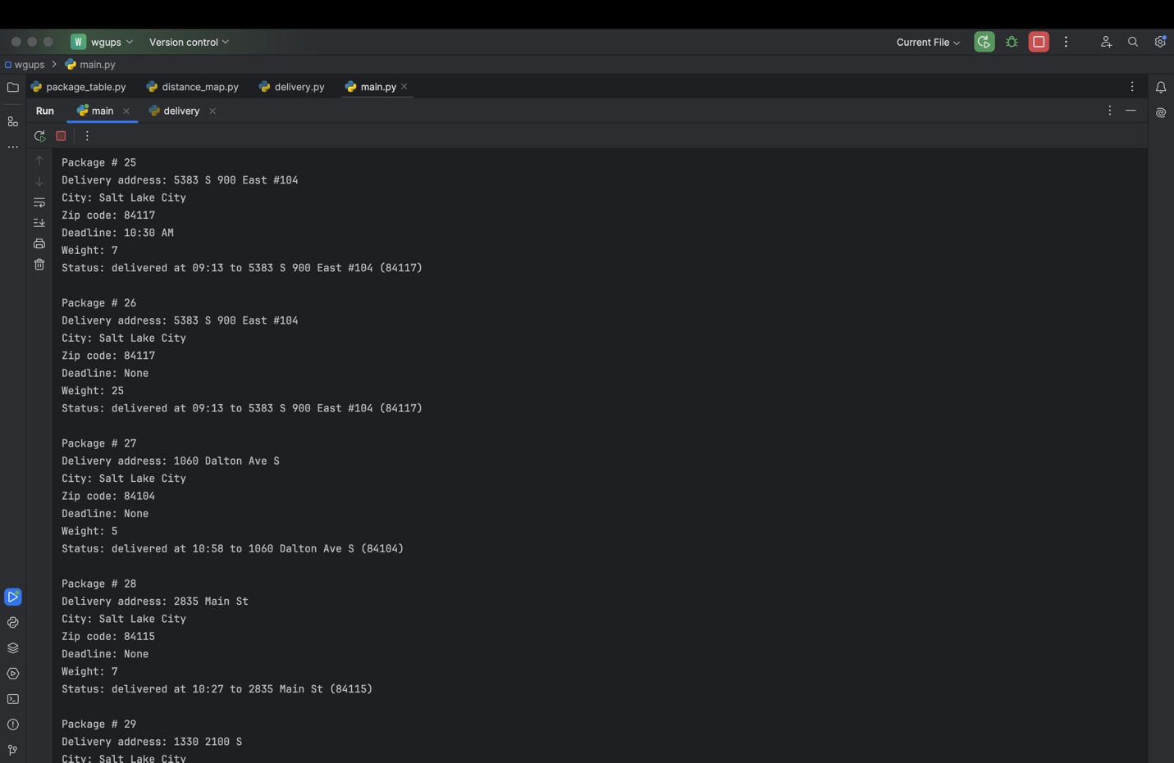

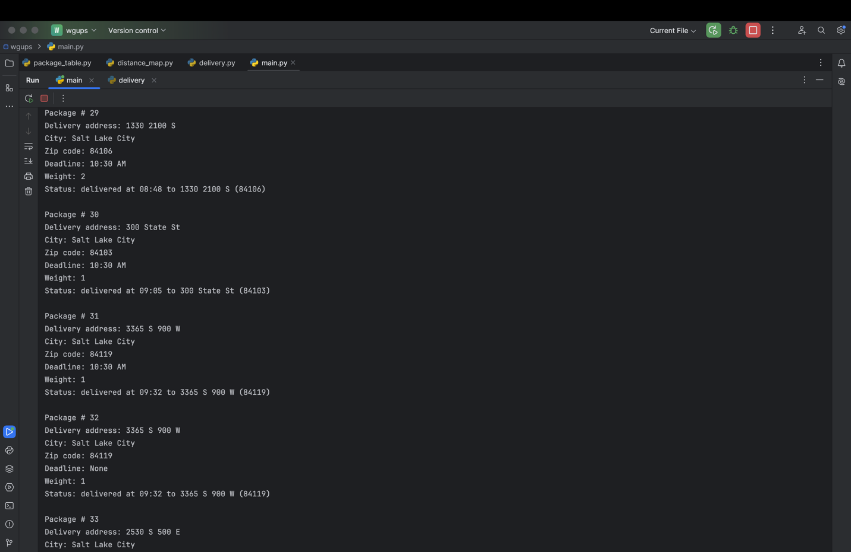

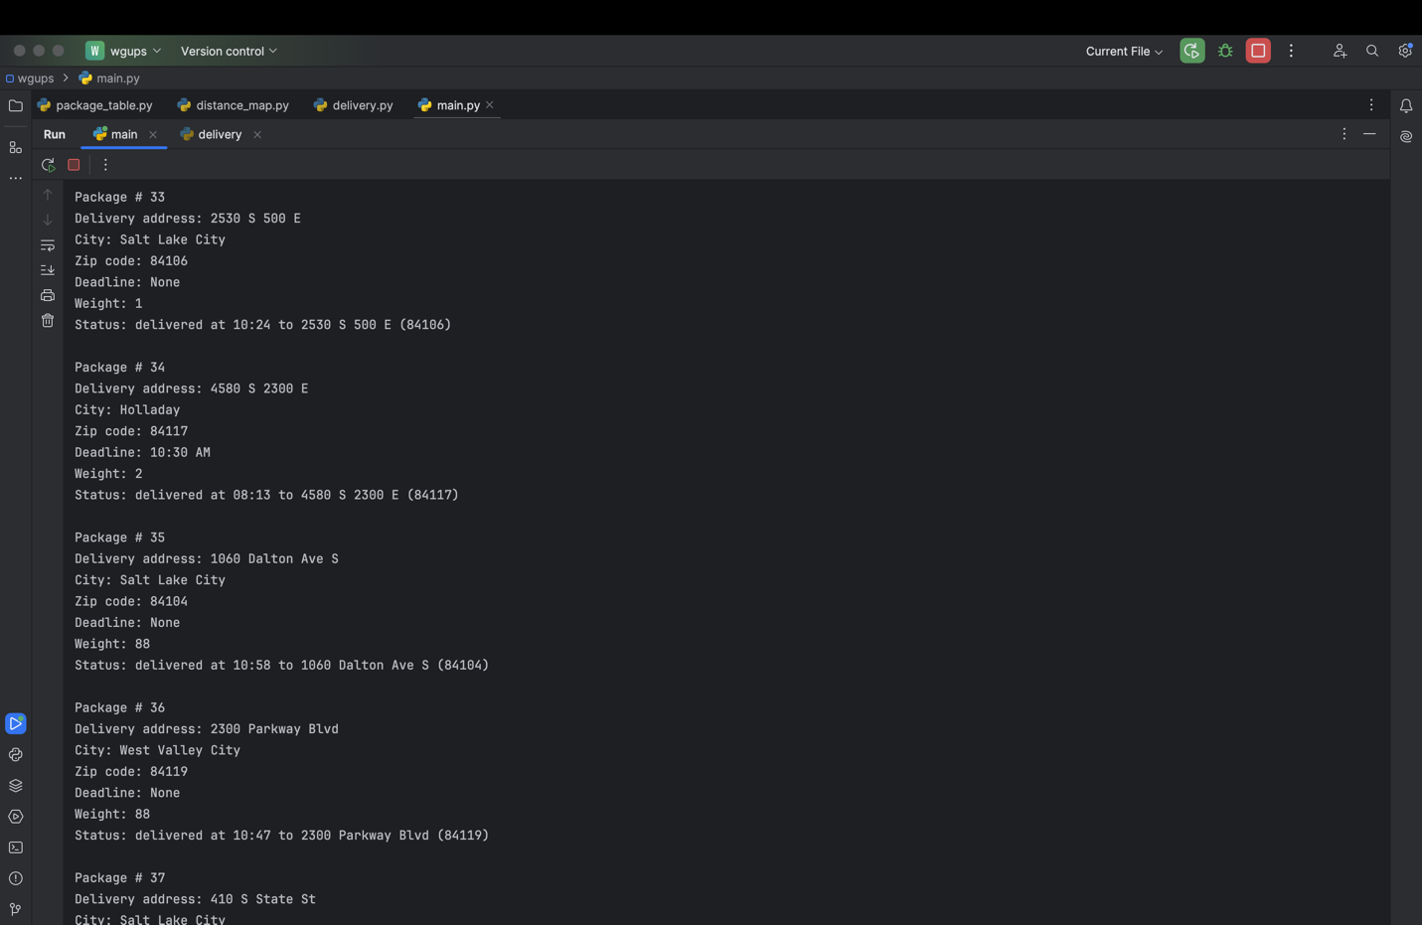

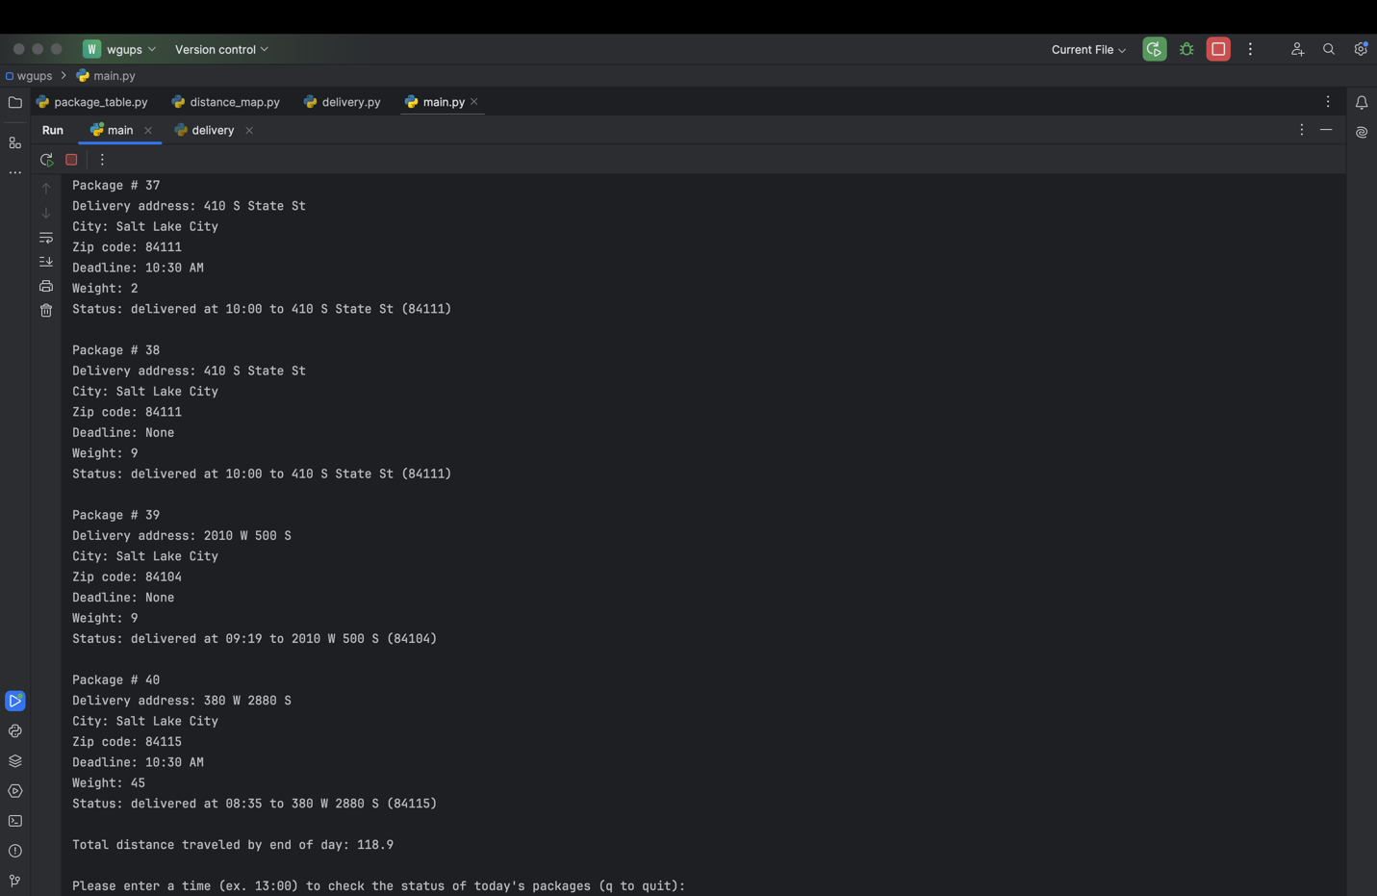

# E. Screenshot of Code Execution

Screenshot goes here

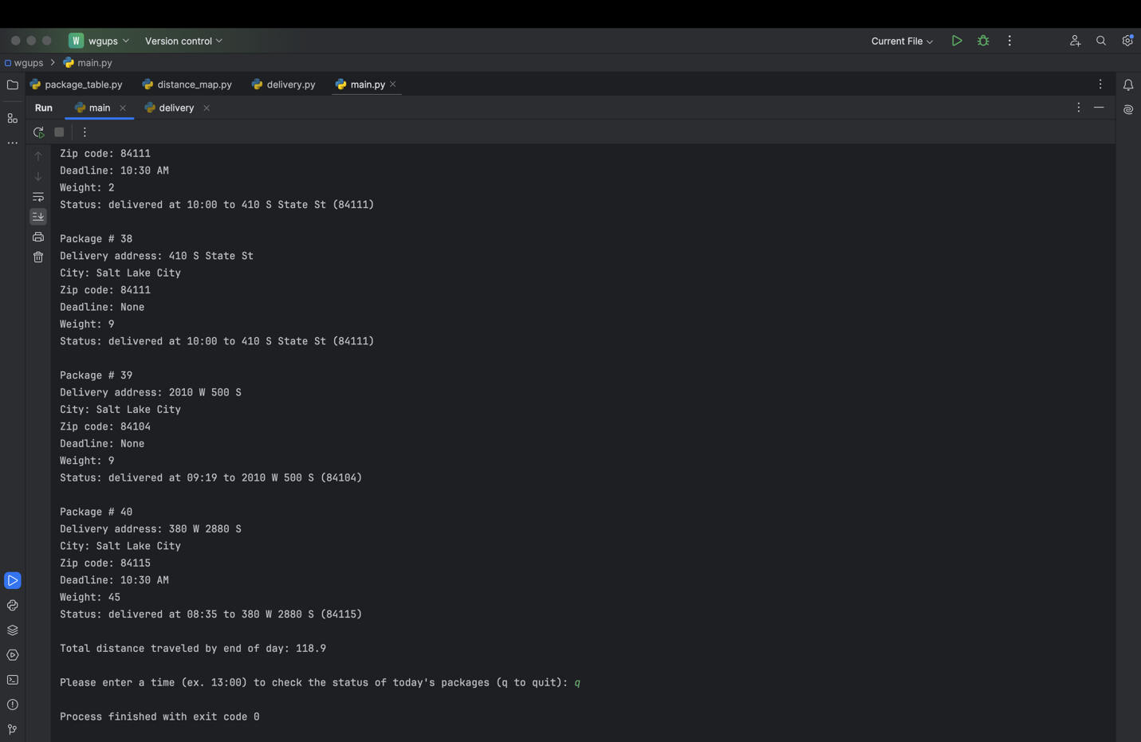

# F1. Strengths of the Chosen Algorithm

The package delivery algorithm I chose to use in my solution was a greedy algorithm that chooses the nearest neighbor from a list of available locations. One strength of this approach is that it offers a quick solution. It’s also straightforward to implement. The approach finds the closest distance from a list of available locations to the current position.

# F2. Verification of Algorithm

The algorithm was able to deliver all packages by their deadlines. Two drivers were used, and three trucks were loaded. Truck 1 returned to the hub before truck 2, so truck 3 was driven by the driver of truck 1. All the packages that needed to be on truck 2 were loaded. The delayed packages left at 9:05 on truck 2. Packages 13, 14, 15, 16, 19, and 20 were all delivered together on truck 1. Package 9 was delivered to the correct address after 10:20. The combined distance of all trucks was 118.9 miles.

# F3. Other Possible Algorithms

Two other algorithms I could have implemented in the solution to meet the requirements described in the scenario include the Bellman-Ford shortest path algorithm and Dijkstra’s shortest paths algorithm.

# F3a. Algorithm Differences

Both the Bellman-Ford and Dijkstra’s algorithms take into consideration predecessor points when choosing a path whereas the algorithm I used only takes into consideration the current location.

# G. Different Approach

If I did this project again, I would have loaded up the trucks within the code. My program already filters out the packages with deadlines and groups packages with the same address as ones with deadlines. I would expand that to include filters that satisfy the special notes section.

# H. Verification of Data Structure

The data structure I used in the solution meets all the requirements in the scenario. I created a hash table that didn’t use any additional libraries or classes from Python. The insert function took in the package ID as specified as an input. Each package ID had its delivery address, deadline, city, zip code, package weight, and delivery status inserted.

# H1. Other Data Structures

A dictionary could have met the same requirements in the scenario. Another approach could have been using an array of arrays where the array stores a specified category of information in a specific index for each package.

# H1a. Data Structure Differences

The dictionary differs from a hash table in that the key would be the package ID. In the hash table, the keys are mapped and stored within a bucket index. An array of arrays is different because the values are stored in an index. The index would serve as the “key” when accessing values.

# I. Sources

Lysecky, R., & Vahid, F. (2012, August). *C950: Data Structures and Algorithms II*. zyBooks.

Retrieved May 27, 2024, from

<https://learn.zybooks.com/zybook/WGUC950Template2023>

# J. Professional Communication